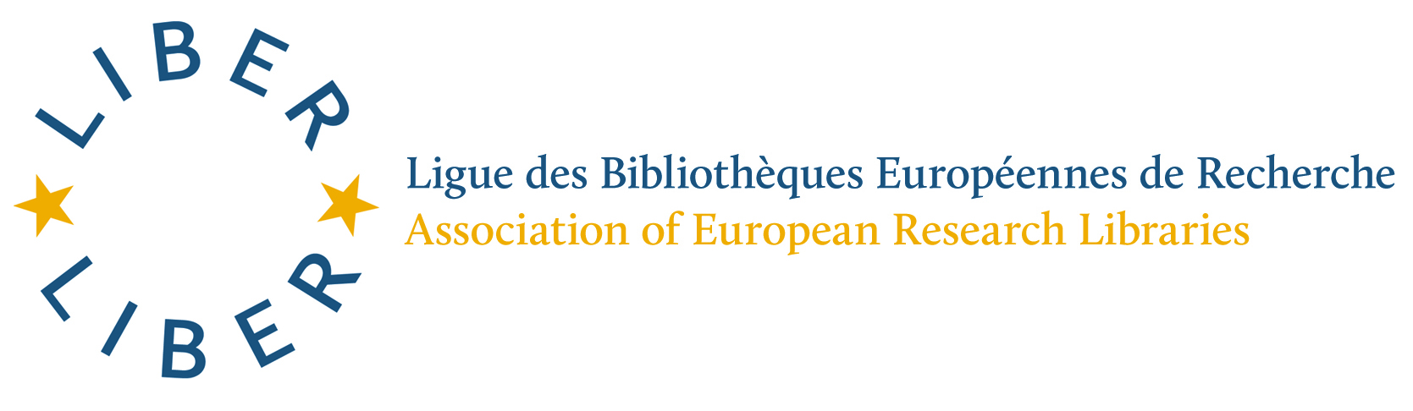

LIBER ANNUAL CONFERENCE, PATRAS 2017
KNOWLEDGE CAFÉ

This to inform LIBER Participants that a Knowledge Café will take place during the LIBER Annual Conference in Patras in July 2017, at which the draft Strategy Roadmap for the LIBER Strategy 2018-2022 will be presented. The Roadmap connects activities and their impact for the Strategy’s three Strategic Directions.

Conference delegates will have the opportunity to discuss the Roadmap during the Knowledge Café and to indicate their priority areas. It is hoped that as many delegates as possible will take this opportunity to discuss the proposed Roadmap and come along.

The Knowledge Café will take place on Wednesday 5 July 2017 from 16:30 to 17.30.

Astrid Verheusen
Interim Executive Director

March 2017

⎯⎯⎯⎯⎯⎯⎯⎯⎯⎯⎯⎯⎯⎯⎯⎯⎯⎯⎯⎯⎯⎯⎯⎯⎯⎯⎯⎯⎯⎯⎯⎯⎯⎯⎯⎯⎯⎯⎯⎯⎯⎯⎯⎯⎯⎯⎯⎯⎯
Stichting LIBER Koninklijke Bibliotheek, P.O. Box 90407, 2509 LK The Hague, The Netherlands. Chamber of Commerce: 27334736

