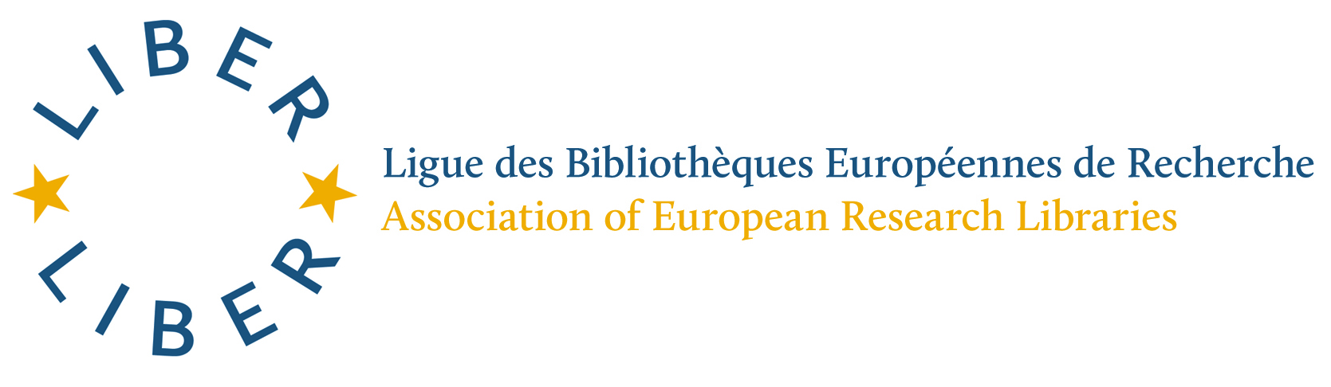

LIBER APPOINTS A NEW EXECUTIVE DIRECTOR

The LIBER Executive Board is very pleased to announce to LIBER Libraries that following its recent recruitment for a new Executive Director, and interviews held in the National Library of the Netherlands in The Hague on 20 November 2014, Ms Susan Reilly has been appointed as LIBER Executive Director. She will take up her post on 1 December 2014.

Ms Reilly has worked for LIBER since 2011, first as EU Projects Officer, then as EU Projects Manager, and as Advocacy and Project Manager, and most recently as LIBER Interim Executive Director with effect from 1 October 2014.

Educated in Ireland, Ms Reilly has a BA (Hons) in Information and Library Studies and Art History from the University of Wales in Aberystwyth, Wales, and an MSc in Information Management from the University of Sheffield.

Before taking up her first post with LIBER in 2011, Ms Reilly was Head Librarian of the Irish Management Institute in Dublin, and she has also worked in other libraries in Ireland.

The interview panel for the post of LIBER Executive Director comprised Ms Kristiina Hormia-Poutanen (President); Ms Jeannette Frey (Vice-President); Dr Van Otegem (Treasurer); and Dr Ann Matheson (Secretary-General), with Drs Dick Langbroek, HR Director, National Library of the Netherlands, in attendance. There was a strong response to the advertisement for the post of LIBER Executive Director, and five candidates were shortlisted for interview.

We congratulate Ms Reilly on her success and look forward to working with her as LIBER’s Executive Director.

Kristiina Hormia-Poutanen
LIBER President

November 2014

⎯⎯⎯⎯⎯⎯⎯⎯⎯⎯⎯⎯⎯⎯⎯⎯⎯⎯⎯⎯⎯⎯⎯⎯⎯⎯⎯⎯⎯⎯⎯⎯⎯⎯⎯⎯⎯⎯⎯⎯⎯⎯⎯⎯⎯⎯⎯⎯⎯
Stichting LIBER Koninklijke Bibliotheek, P.O. Box 90407, 2509 LK The Hague, The Netherlands. Chamber of Commerce: 27334736

