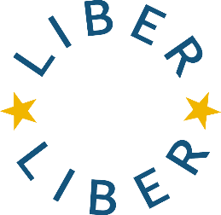

Improving Open Access practices in European research Libraries – LIBER Cascading Grants

Application Form

Please complete this form and send it in a pdf. format, with all the necessary documents attached, to:

calls@libereurope.org

Closing date: Friday, 20 February 2026, 23:59 CET

General information
Library Name

LIBER ID

Contact person

Proposal
Title (Name of the idea or project)

Each of the following sections should be between 300 and 600 words

Relevance
Please describe the challenge that your community encountered and how it was addressed. How does your proposal relate to the actions outlined in the LIBER Action Plan? Please specify the relevant action points.

Implementation
Please describe what kind of resources have been used and how.

Impact
Please describe what the impact is. If it is an ongoing project in your library, what are the expected outcomes? What are the lessons that one can take from your activities?

By applying for the LIBER Cascading Grants 2026, I confirm, if my library is accepted, that:
- I confirm that my home library will be available for the purposes and deliverables outlined in the Call for Participation and will commit to the expected activities for the duration of the grant period.

Signatures:

Contact person Date

Name

The director of the library Date

Name

By signing this form, the director of the library recognises that they have the authority to commit their library and that they five full support for this grant application.

